**The Chosen**-

“Seeing Jesus Through the Eyes of Those Who Knew Him”

***YOU are invited!***

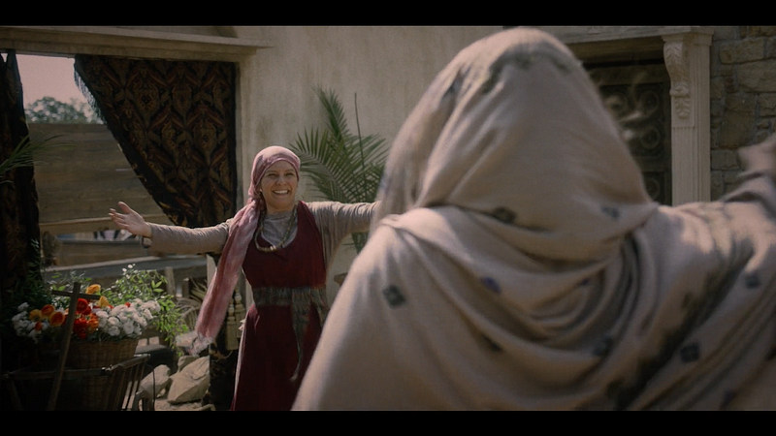

**Thursday, Nov. 21, 7:00 pm**  
at The Junction  
47 Arthur Street S, Elmira

SEASON ONE: Episode 5  
***The Wedding Gift***

* Watch the movie (54 min)
* Enjoy some free popcorn & pop
* Time for conversation, a game of pool or ping pong, working on a puzzle…

Episode 6: Nov. 28